International School

Database Design and Data Mapping Document
Course: System Integration Practices
Project Title: Integrated HR & Payroll Dashboard System for Company X
Case Study 2: Models Integration
Version: 1.0
Date: [Insert Date]
Group: [Enter Group Name / Group Number]
Semester: 2 – Academic Year 2024–2025
Instructor: MSc. Nguyen Dang Quang Huy
Team Members:
Name | Student ID
Hoang, Tran Thi Khai | 27205621505
Hung, Truong Thanh | 27211240268
Lich, Huynh Ngoc | 27211201526
Manh, Nguyen Tien | 27211238929
Sung, Quoc Hoang Lam | 27211200383

Approved by
MSc Huy, Nguyen Dang Quang
Group Project - Instructor:

Name Signature Date

Da Nang 05/2025
Project Acronym | HRD
Project Title | Company X – Integrated HR & Payroll Management Dashboard
Start Date | 17 April 2024 | End Date | 20 August 2024
Lead Institution | International School, Duy Tan University
Role | Name | Email |  | Phone
Project Mentor | Nguyen Dang Quang Huy
 | Nguyen Thanh Nhan | hashayi147@gmail.com |  | 0379740995
 | Phan Quang Tuan | tuanphana202@gmail.com |  | 0866103702
 | Tran Thi Thu Hong | Ttthuhong123@gmail.com |  | 0833282777

DOCUMENT NAME
Document Title | API Integration Plan Document
Reporting Period | 17– April - 2024
Author(s) | Phan Quang Tuan  Tran Thi Thu Hong  Nguyen Thanh Nhan
Role | Developer
Date | 17/04/2024 | File name | 5. API Integration Plan.docx

DOCUMENT APPROVALS
Document Approvals: The following signatures are required for approval of this document.
Mentor | Huy, Nguyen Dang Quang | Signature:
 |  | Date:
 |  | Date:
Team member(s) | Nhan, Nguyen Thanh | Signature:
 |  | Date:
 | Tuan, Phan Quang | Signature:
 |  | Date:
 | Hong, Tran Thi Thu | Signature:
 |  | Date:

TABLE OF CONTENTS
1. Introduction 6
1.1 Purpose 6
1.2 Scope 6
1.3 Definitions, Acronyms, and Abbreviations 6
1.4 References 6
2. System Overview 7
3. Database Description 7
3.1 HUMAN Database Schema 7
3.2 PAYROLL Database Schema 8
4. Data Mapping Specification 8
4.1 Employee Data Mapping 8
4.2 Department Data Mapping 9
4.3 Attendance Data Mapping 9
5. Integration Logic Explanation 9
6. Entity Relationship Diagram (ERD) 10
7. Summary and Future Work 10

1. Introduction

1.1 Purpose
This document provides a detailed description of the database structures for the HUMAN and PAYROLL systems. It serves as the primary technical foundation for data mapping and integration logic, ensuring that API synchronization between SQL Server and MySQL is accurate and consistent.

1.2 Scope
The scope of this document is limited to describing the database schemas and the logical mapping between the two systems. It does not cover the actual API source code, user authentication mechanisms, or system security protocols.

1.3 Definitions, Acronyms, and Abbreviations
Liệt kê các thuật ngữ, từ viết tắt được sử dụng trong tài liệu.
Hướng dẫn sinh viên viết:
- Ví dụ Tạo bảng như sau:
Acronym/Term | Definition
HUMAN | Human Resource Management Database (SQL Server)
PAYROLL | Payroll Management Database (MySQL)
PK | Primary Key
FK | Foreign Key
ER | Entity Relationship Diagram

1.4 References
- Case Study 1 – Problem Statements
- Software Requirement Specification (SRS) Document
- IEEE Std 1016-2009 – Standard for Software Design Descriptions
- CMU-CS445 Course Material, Duy Tan University (2025)

2. System Overview
The integration project involves two primary systems: the HUMAN system, which manages organizational structures and employee profiles, and the PAYROLL system, which handles financial compensation and attendance.
Cung cấp bối cảnh và tóm tắt chức năng của hai hệ thống sẽ tích hợp.
Hướng dẫn sinh viên viết:
- Mô tả chức năng của HUMAN (quản lý nhân sự) và PAYROLL (tính lương).
- Tạo bảng tóm tắt:
System | Database Type | Main Tables | Role in Integration
HUMAN | SQL Server | EMPLOYEE, DEPARTMENT, ATTENDANCE | Source of employee data
PAYROLL | MySQL | PAYROLL, SALARY_DETAIL, DEDUCTION | Destination for payroll records

3. Database Description

3.1 HUMAN Database Schema
Trình bày chi tiết cấu trúc các bảng trong hệ thống HUMAN.
Hướng dẫn sinh viên viết:
- Liệt kê các bảng: EMPLOYEE, DEPARTMENT, ATTENDANCE, trước mỗi bảng phải giải thích rõ bảng đó là gì
- Mỗi bảng có cột: Field Name, Data Type, Key, Description.
Mẫu bảng:
Field Name | Data Type | Key | Description
EmployeeID | VARCHAR(10) | PK | Unique employee identifier
FullName | NVARCHAR(100) |  | Employee name
DepartmentID | VARCHAR(10) | FK | Department reference
HireDate | DATE |  | Start date of employment

3.2 PAYROLL Database Schema
Trình bày cấu trúc của hệ thống PAYROLL.
Hướng dẫn sinh viên viết:
- Liệt kê các bảng: PAYROLL, SALARY_DETAIL, DEDUCTION… trước mỗi bảng phải giải thích rõ bảng đó là gì
- Ghi rõ quan hệ PK/FK giữa các bảng.
Mẫu bảng:
Field Name | Data Type | Key | Description
PayrollID | INT | PK | Unique payroll record ID
EmpNo | VARCHAR(10) | FK | Employee number reference
Month | CHAR(7) |  | Payroll month
BasicSalary | DECIMAL(12,2) |  | Base monthly salary
Bonus | DECIMAL(12,2) |  | Performance bonus

4. Data Mapping Specification

4.1 Chức năng in danh sách nhân viên

Employee Data Mapping
Mô tả cách ánh xạ dữ liệu nhân viên giữa HUMAN và PAYROLL.
Hướng dẫn sinh viên viết:
- Tạo bảng với các cột: HUMAN Table, Field, PAYROLL Table, Field, Mapping Description.
Mẫu bảng ánh xạ:
HUMAN Table | Field | PAYROLL Table | Field | Mapping Description
EMPLOYEE | EmployeeID | PAYROLL | EmpNo | Primary key mapping
EMPLOYEE | FullName | PAYROLL | EmpName | Direct value copy
EMPLOYEE | DepartmentID | PAYROLL | DeptCode | Used for department grouping

4.7 Function: HR & Attendance Analytics

HUMAN Table | Field | PAYROLL Table | Field | Mapping Description
Employees | EmployeeID | attendance | EmployeeID | PK Mapping is used to match personnel and time sheets
Departments | DepartmentsName | N/A | N/A | Use department names to group data.
N/A | N/A | attendance | WorkDays | Get the actual number of working days from MySQL
N/A | N/A | attendance | AbsentDay | Use the number of absent days to create a chart showing the absenteeism rate by department.
4.8 Function: Payroll Distribution

HUMAN Table | Field | PAYROLL Table | Field | Mapping Description
Employees | EmployeeID | salaries | EmployeeID | PK Mapping to match personnel and payroll
Positions | PositionName | N/A | N/A | Data grouping by job title
Departments | DepartmentName | N/A | N/A | Calculate the total payroll for each department.
N/A | N/A | salaries | NetSalary | Core financial data for calculating SUM/AVG
4.9 Function: Total Compensation & Dividend

HUMAN Table | Field | PAYROLL Table | Field | Mapping Description
Employees | EmployeeID | salaries | EmployeeID | PK Mapping connects Shareholders and Payroll.
Employees | FullName | N/A | N/A | Display the name of the insider shareholder.
Dividends | DividendAmount | N/A | N/A | Dividend amount
N/A | N/A | salaries | NetSalary | Cộng với Lương ròng (MySQL) để ra Biểu đồ Tổng thu nhập cuối năm

5. Integration Logic Explanation
Giải thích quy trình sử dụng bảng ánh xạ trong tích hợp dữ liệu.
Hướng dẫn sinh viên viết:
- Viết 2–3 đoạn mô tả quy trình HUMAN → PAYROLL, cách API đồng bộ và cách xử lý lỗi.
Gợi ý biểu đồ luồng:
[HUMAN DB] --> [API Integration Layer] --> [PAYROLL DB]
Module: Reporting & Analytics
In the Reporting & Analytics module, the integration logic does not follow a traditional one-way synchronization. Instead, it employs a Parallel Data Aggregation and In-memory Merging mechanism through a centralized Python-based API layer. This process is executed through three distinct phases:
Phase 1: Multi-source Data Extraction
Upon receiving a request from the React Dashboard (e.g., GET /api/reports/payroll-distribution), the Python Backend initiates two concurrent connection threads:
- HR Data Retrieval: Utilizes the pyodbc library to query identification and organizational data (FullName, DepartmentName, PositionName) from the HUMAN_2025 system (SQL Server).
- Payroll Data Retrieval: Utilizes the mysql-connector-python library to fetch financial and timekeeping records (NetSalary, WorkDays) from the PAYROLL system (MySQL).
Phase 2: Data Mapping and Merging Logic
Once the raw data is retrieved into the Backend as DataFrames (using the Pandas library), the system uses EmployeeID as the Primary Join Key to bridge the two datasets.
- Merging Strategy: A Left Join operation is performed, using the HR database as the master source to ensure all active employees are represented.
- Null Handling: If an employee exists in HR but lacks a corresponding record in the Payroll system, the logic automatically assigns default values (e.g., 0 or N/A) to prevent rendering errors on the frontend charts.
- Aggregation: The merged dataset is then grouped by department or position, applying aggregate functions (SUM, AVERAGE) to generate the final analytical metrics.
Phase 3: Response Formatting and Error Handling
The consolidated data is serialized into an optimized JSON format and transmitted to the Frontend for visualization.
- Exception Handling: To ensure system resilience, all integration points are wrapped in try-except blocks. If one database becomes unreachable (e.g., a MySQL timeout), the API returns a standardized error code (HTTP 500 or 503) and logs the incident, rather than crashing the entire Dashboard.
Data Integration Flowchart:
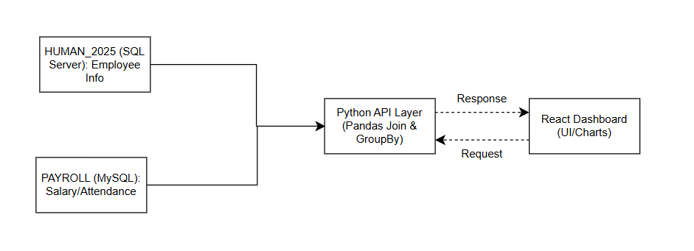

6. Entity Relationship Diagram (ERD)
Minh họa quan hệ PK-FK giữa các bảng của hai hệ thống.
Hướng dẫn sinh viên viết:
- Vẽ ERD bằng Draw.io, Lucidchart hoặc PowerPoint.
- Chèn hình sơ đồ ERD vào đây
Module: Reporting & Analytics
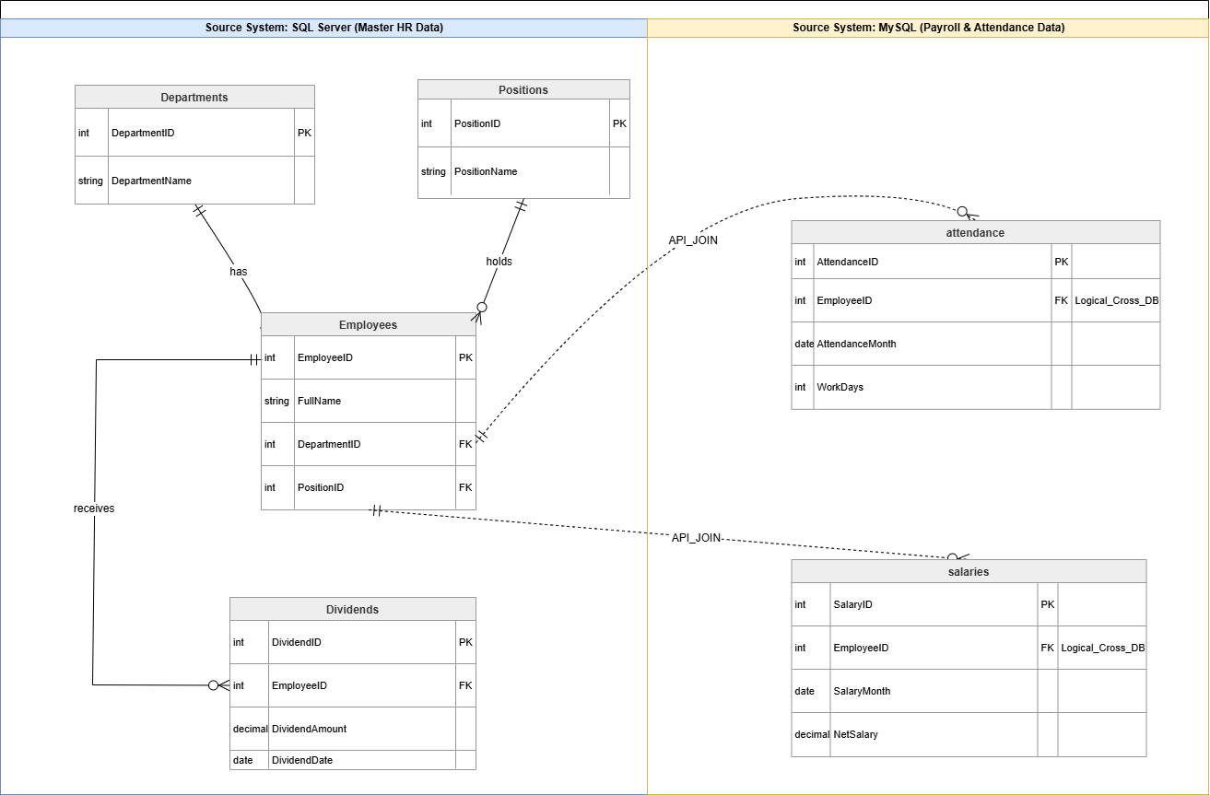

7. Summary and Future Work
Tóm tắt nội dung đã hoàn thành và định hướng cho Case Study 3.
Hướng dẫn sinh viên viết:
- Viết 1 đoạn: nhấn mạnh ý nghĩa của mapping trong tích hợp API.
- Gợi ý: “This document defines the structure and mapping logic used for RESTful API integration.”
7.1. Project Overview
The Integrated HR & Payroll Dashboard project was initiated to resolve the critical challenge of data fragmentation within the organization. By bridging two historically isolated systems—HUMAN_2025 (SQL Server) for master HR records and PAYROLL (MySQL) for financial and attendance data—the project has successfully created a unified "Single Source of Truth." This integration allows stakeholders to access comprehensive insights that were previously locked in disparate silos.
7.2. Technical Implementation Summary
The core of this project lies in its Hybrid Middleware Architecture.
- The Backend (Python Integration Layer): Acts as the brain of the system, utilizing advanced data orchestration techniques (via Pandas and SQLAlchemy) to perform cross-database joins and real-time data aggregation.
- The Frontend (React Dashboard): Provides a modern, responsive interface that transforms raw integrated data into interactive visualizations, enabling intuitive decision-making for management.
- Data Consistency: By establishing a Logical Mapping based on the EmployeeID across heterogeneous platforms, the system ensures high data integrity without the need for expensive and risky database migrations.
7.3. Business Value & Outcomes
The successful implementation of this integrated system delivers three primary benefits:
- Operational Efficiency: Eliminates the need for manual data reconciliation between HR and Payroll departments, reducing human error and administrative overhead.
- Cross-Functional Analytics: For the first time, the organization can analyze the direct correlation between employee performance (from HR) and financial compensation (from Payroll) through a single interface.
- Scalability: The architecture is designed to be modular, allowing for future integrations with other corporate systems (such as ERP or CRM) with minimal disruption to existing workflows.
7.4. Final Conclusion
In conclusion, the Integrated HR & Payroll Dashboard is more than just a reporting tool; it is a strategic asset that empowers the organization with data-driven agility. While the project navigated significant technical hurdles regarding data heterogeneity and system connectivity, the final result stands as a robust, scalable, and secure solution that meets the modern demands of corporate data management.

